AP Psychology – brain parts
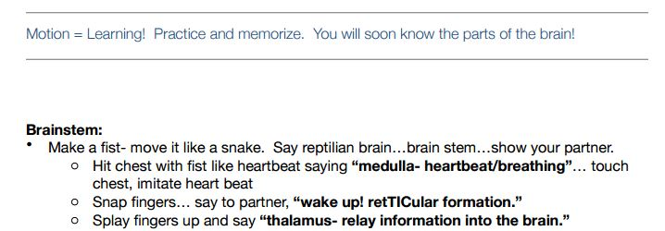
- Pons : grab the snake, move it, and say “pons – voluntary movement”
- Cerebellum: make a fist with other hand, move it from side-to-side around your other fist, say “cerebellum – timing, coordination, smooth movement, tiny brains”
